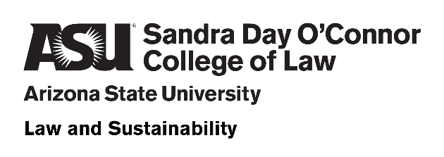

Ninth Annual SRP Sustainability Conference of
American Legal Educators
May 9-10, 2024

Registration and Table Sponsorship now available
Hosted by the Law and Sustainability Program
at Arizona State University’s Sandra Day O’Connor College of Law
The SRP Sustainability Conference of American Legal Educators is the premier annual gathering of law professors presenting the latest research on environmental sustainability. Topics include climate change law, environmental law, energy law, water law, natural resources law, land use and zoning law, agricultural and food law, and disaster law, just to name a few. This year’s conference kicks off with a pre-conference dinner on Thursday, May 9, and continues Friday, May 10, with a full day of presentations, eligible for up to 7 hours of CLE credit. If you want to know where we are and where we’re headed from the leading sustainability law scholars, you will not want to miss this event.
Morrison Prize Lecture: |  | Register Here | General Admission | Gov’t or Non-Profit
Kerrigan Bork  Water Right Exactions  Harvard Environmental Law Review  (2003) |  | Admission to Friday Sessions (no CLE, breakfast and lunch included) | $100 | $50
 |  | Friday admission plus Thursday Pre-Conference Dinner (no CLE credit) | $175 | $125
 |  | Friday admission with up to 7 hours of CLE credit* (no Thursday dinner) | $250 | $125
 |  | Admission with both the Thursday Dinner and up to 7 hours of CLE credit* | $325 | $200
*The State Bar of Arizona does not approve or accredit CLE activities for the Mandatory Continuing Legal Education requirement.

Support the Program by Becoming a Table Sponsor
Sponsor a table at  the conference dinner  May 9 | As a table sponsor for $1,000, your organization will receive:  • Recognition as a conference sponsor  • Six (6) free registrations, including CLE credit, for the entire conference (FMV: $1,950)
Contact Troy Rule at Troy.Rule@asu.edu for more information.

Sponsorship Response Form

Ninth Annual SRP Sustainability Conference of American Legal Educators
May 9-10, 2024

I am pleased to support the Ninth Annual SRP Sustainability Conference of American Legal Educators, on May 9-10, 2024, and the Law and Sustainability Program at Arizona State University’s Sandra Day O’Connor College of Law as a Table Sponsor with a sponsorship pledge of $1,000.

My check is enclosed. Please make payable to “ASU Foundation” and mail to:

Sandra Day O’Connor College of Law
Mail Code 9520
111 East Taylor St.
Phoenix 85004-4467
Attn: Tricia Hilbun

You may pay by credit card here or contact Tricia Hilbun at 602-326-7390 (“ASU Foundation” will appear on your statement):

SPONSOR INFORMATION
Sponsor or Company Name* (as it should appear in our printed and online materials):
Address: | City: | State: | ZIP:
Phone Number: | Fax Number:
Email Address: | Contact Person:

All funds will be deposited with the ASU Foundation for A New American University, a nonprofit organization that exists to support Arizona State University (ASU). Gifts in support of ASU are subject to foundation policies and fees. Due to the fair market value of benefits received, only payments in excess of fair market value may be considered a charitable contribution. Please consult your tax advisor regarding the deductibility of charitable contributions.

